Harpreet Sidhu

Reuel Maddela

Charles Henderson

Bass

Activity 12

Screenshot of breakpoint in OnAuthorization method: 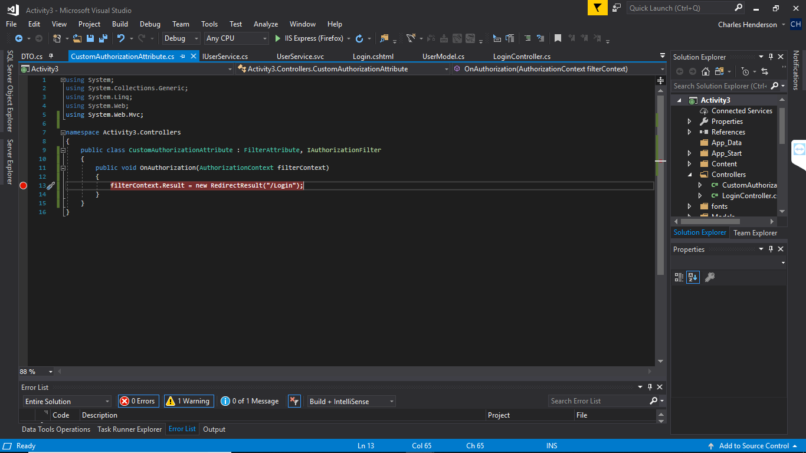

Screenshot of breakpoint again while running in debug mode: 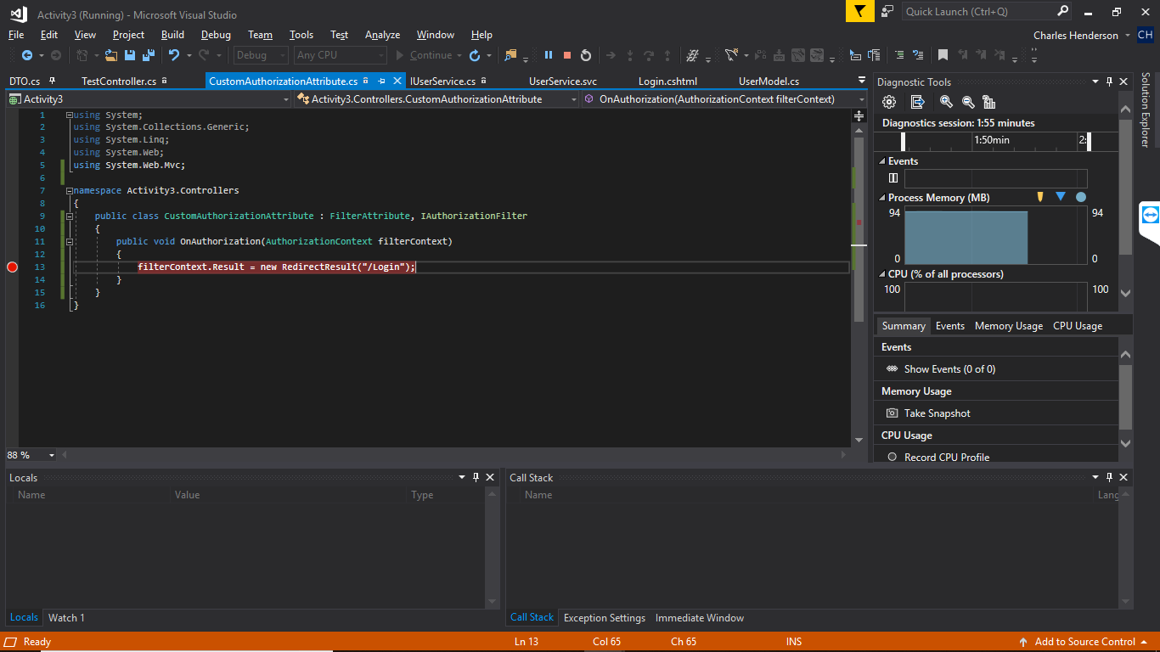

Custom Login Logger that tracks redirecting to login page: 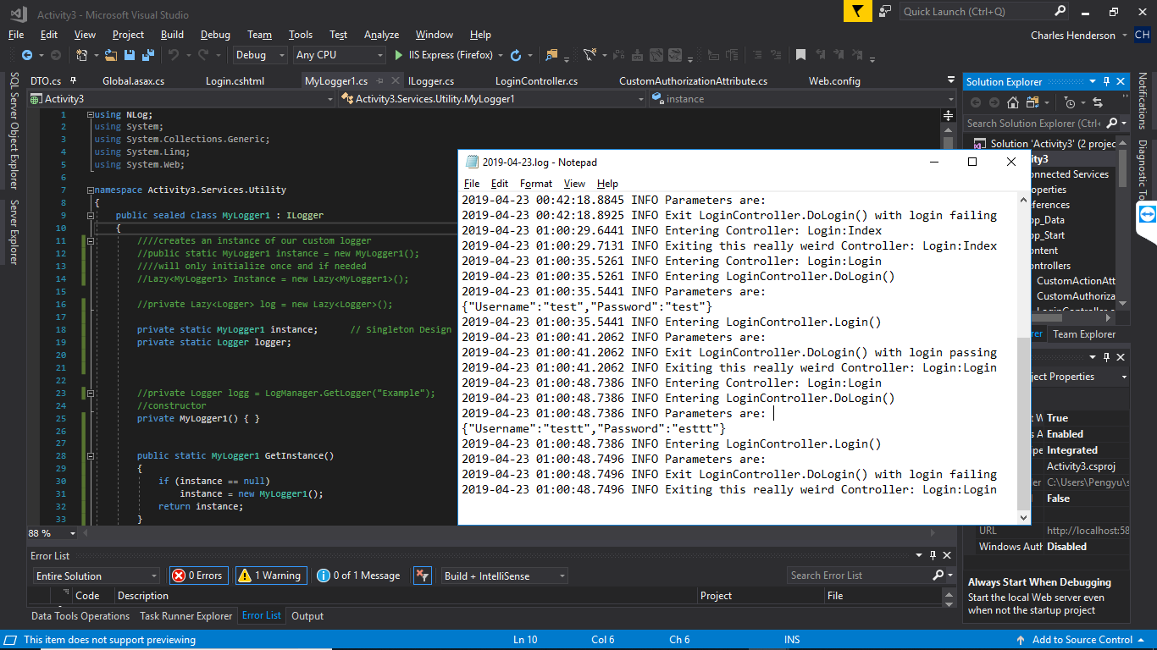

Log of users being placed into cache: 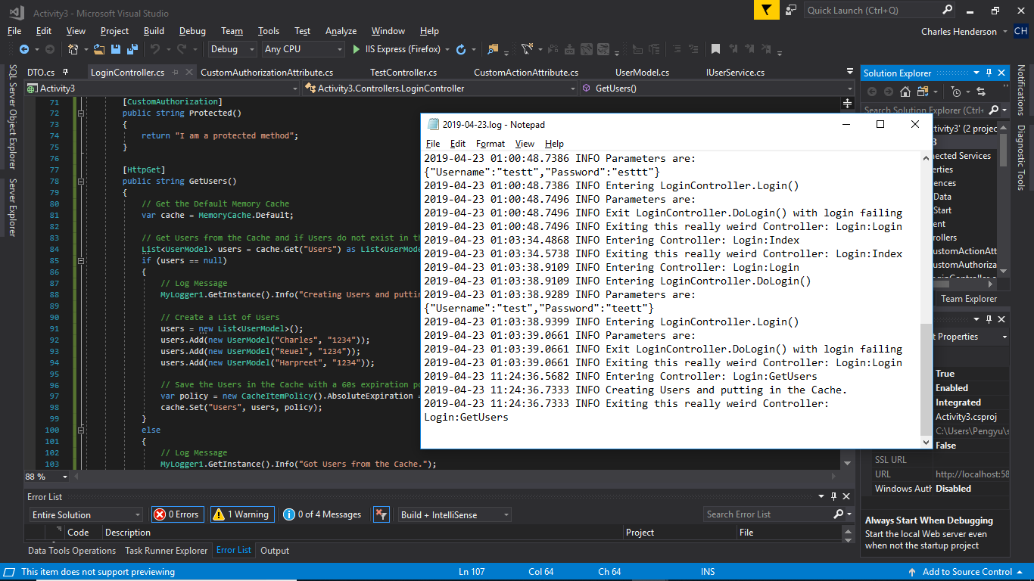

Breakpoint hit within Get All Users method in Hello World Service: 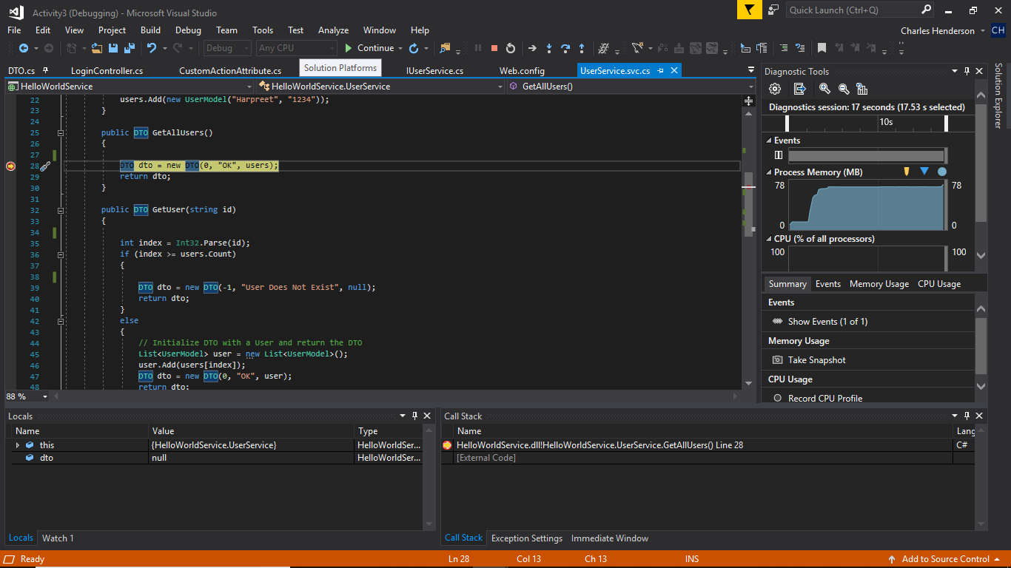

Users can be grabbed for 60 seconds: 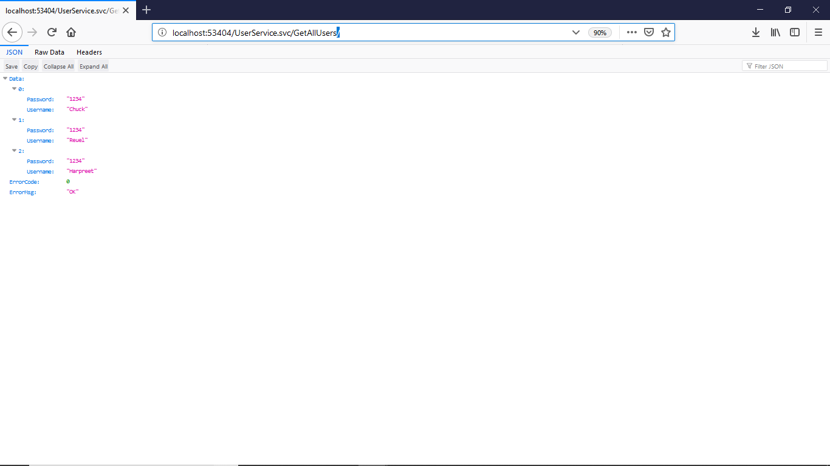

Operation Breaks after 60 seconds and goes back to refresh user list: 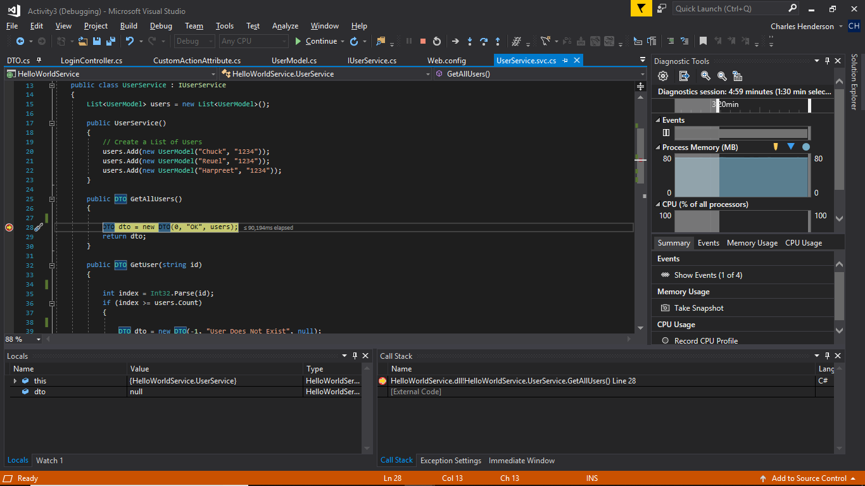

https://github.com/agingdanger/CST-247